Mathematical Module-
1] Representation by using sets as shown below
U= {I, P, V, G, O};
Here,
U=set required for overall process;
I=set of input object;
I= {I1};
P=set of trajectory points;
P= {p1, p2, ......,pn};
V=set of vectors;
V= {v1, v2, .....,vn};
G=set of gestures;
G= {g1, g2, .......,gn};
O=set of operations;
O= {o1, o2, ........on};

2] Functions Required For Overall Execution
Trajectory Point Generator:
f1 (I,n)- - -> P
This Function takes input as an object and generates the point trajectory at “n” regular intervals.
Computation of the vectors:
f2 (P[n], P [n+1]) ---> V
This function takes two parameters i.e. a pair of consecutive points. The direction along which the object is moving can be calculated alongwith the slope for all the pairs of consecutive points. Thus we get a vector having a direction and slope. Generated vectors are stored in the vector set V.
Representation of gestures using combination of vectors:
f3 (V) ---> G
This function represents and associates one or more vector from the vector set V with the gesture set G.
Association of gestures with operations:
f4 (G) ---> O
This function associates the gestures with the operations to be performed.

3] Association between functions by using domains and co-domains
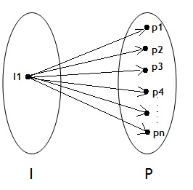
The above figure shows one-to-many relationship for the set of Object and Points. One Object will pass through a number of points while performing a gesture. The function f1 (I)- - -> n is represented using the above figure.
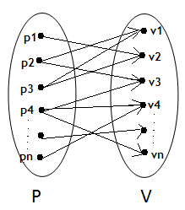
The above figure shows many-to-many relationship for the set of Points and Vectors. A set of points constitutes a Vector (i.e. having direction and slope). A set of points may be repeated in one or more vectors. The function f2 (P[n], P [n+1]) ---> V is represented using the above figure.
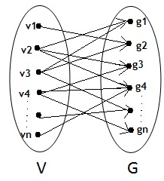
The above figure shows many-to-many relationship for the set of Vectors and Gestures. A set of Vector (i.e. having direction and slope) constitutes a Gesture. The function f3 (V) ---> G is represented using the above figure.

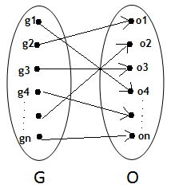
The above figure shows one-to-one relationship for the set of Gestures and Operations. Every gesture is associated with a separate operation. The function f4 (G) ---> O is represented using the above figure.

